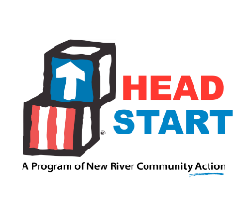
New River Community Action, Head Start
Policy Council
Minutes of the Meeting
April 18, 2023
ATTENDANCE | Electronic votes of members were captured on April 18, 2023.  Members who voted electronically:  Leah Riddle – _{Rich Creek} Sarah Smith – _{Radford 1st B}  Jennifer Brown – _{Floyd/Check} Stephanie Smith – _{Community Rep}  Xuan Lin – _{ELC} Mario Solorio – _{Community Rep}
NEW BUSINESS | Finance found an error in the approved COLA and Quality Proposal Budget. The admin cost exceeded 15% of the budget. Finance revised the budget. The revised budget was emailed to the Policy Council Representatives. The revised budget adjusted this error and showed the number of hours for the aide position went from 20-30 hours and made the AT position an Education Advocate position to help with recruitment, attendance, and educational visits. The $710 remaining was added to the Staff wellness line item. The budget balances.  The members voted electronically and approved this revision of the COLA and Quality Proposal Budget.  Respectfully submitted,  Leah Riddle - Chairperson

