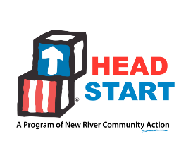
New River Community Action, Head Start
Policy Council
Minutes of the Meeting
May 10, 2023
ATTENDANCE | Electronic votes of members were captured on May 10, 2023.  Members who voted electronically:  Leah Riddle -_{Rich Creek} Constance Burton-_{Radford/McHarg}  Xuan Lin – _{ELC} Jennifer Brown – _{Floyd/Check}  Sarah Smith – _{1st Baptist} Stephanie Smith – _{Community Rep}  Ana Alexander - _{Pulaski}
NEW BUSINESS | The Policy Council members were presented with the Health and Safety Proposal and Budget, electronically. The proposal included a one-time funding request for $98,295 to include the following safety items:  - Improving/replacing entrance doors to make them more secure. (Christiansburg)  - Tinting of windows to make them less transparent/more difficult to see through from the outside. (Pulaski)  - Security cameras/call boxes at main entrances. (Multiple Head Start facilities)  - Routine testing of water at Center facilities for lead content. (Multiple Head Start facilities)  The members voted electronically and approved the request for the Health and Safety Proposal.  Respectfully submitted,  Leah Riddle - Chairperson

