July Policy Council Minutes
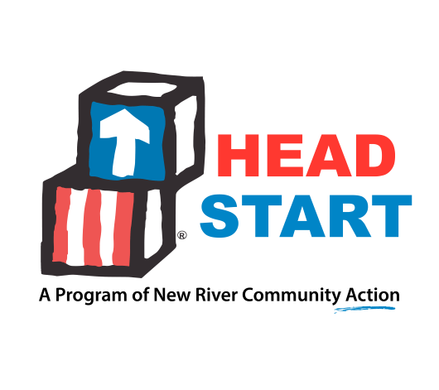

NRCA Head Start Policy Council
Jul 10, 2023 at 5:30 PM EDT
@ 215 3rd Ave. Radford, VA 24141

Attendance
Present:
Members: Ana Alexander, Jennifer Brown, Constance Burton, Kristy Castanon, Roni Fitch, Leah Hill, Stephanie Smith
Absent:
Members: Xuan Lin, Leah Riddle, Sarah Smith, Mario Solorio
- Call to Order

Meeting was called to order at 5:49pm.
- Roll Call
- Agenda Review
- Minutes from Last Meeting: May 22, 2023
May Policy Council Minutes.pdf
Motion:
Motion to approve May 22, 2023 minutes as is.

Motion moved by Ana Alexander and motion seconded by Jennifer Brown. All in favor. Motion carried.
- NRCA Board Meeting Minutes: May 2023
NRCA May 2023 Minutes signed.pdf
- Director’s Report: Roni Fitch – NRCA Director of Early Childhood/Family Services
PC and Board Report June 2023.doc
PC and Board Report July 2023.doc
2023 Monthly Enrollment Report - July 2023 (2).xlsx

Veronica Fitch reviewed the reports. The program is currently looking to hire staff. Had 22 vacant positions. 3 have been hired and 4 are in the waiting process of getting background checks back before position can officially be offered. We must have staff before we can accept anymore children. Members commented if Covid was still the problem with staff shortages. Are the salaries holding people back from applying? Some locations still do not have transportation, is that a problem with families not applying? Shortage in CDL drivers, Kristy Castanon did explain the CDA process and encouraged members to tell their friends about the incentives of getting their CDA. Roni shared that the CEO, Krystal Thompson is resigning and her last day is July 28th. Since Head Start does pay for 52% of the CEO salary, Policy Council members will have to approve the Board's recommendation before applicant could be offered position. Ana Alexander is on the personnel committee of Board, so will more than likely be a part of the interview process.
- New Business
  - TSG Report (Period 3) - Dr. Kristy Castanon

Kristy reviewed the period 3 TSG report that the members were provided. She did note that only about of the forth of the students enrolled were returning students and their second year with Head Start. She also noted the substantial increase in 4-year-old social emotional and math domains.
  - Facilitated Self -Assessment Conversation - Dr. Kristy Castanon

Kristy led the discussion around the Self-Assessment. She wanted to get feedback from Policy Council of their opinion on how to retain staff. Suggestions included: "going to have to pay teachers more", "they feel unappreciated and underpaid." Ways to support them: they would get pay increases on how long they have been there, give an overall increase to all staff, wellness fringe benefits: time off to go get nails done without having to use PTO. Other suggestions included having a big party to celebrate teachers and Policy Council could sponsor it. Could the "Give Big Days" be geared towards teacher appreciation, special table in cafeterias with snacks for teachers and give more PTO.
Kristy also asked the question, how could the program support regular daily attendance? Input included: need to provide transportation in more locations, staff check in with parents making sure their mental health is good.
What challenges occur that prevent families from sending their child to school regularly: waking up late, parents are depressed, not having transportation, parents not understanding the resources available to them.
- Adjournment of the Meeting

Meeting was adjourned at 7:14pm.
- Next Meeting: Tuesday, September 19, 2023 at 5:30pm Location TBD

